# 1. Introduction

# Project Title: LearnHub:Your Center for Skill Enhancement Team Members:

# Gavini Venkata Murali Krishna

# Deepika Mukku

# Darsi Balaji

# Darla Sandhya

# 2. Project Overview

# Purpose: To build a responsive, user-friendly online learning platform that enables students to learn new skills via video lectures, reading materials, and interactive elements, while providing tools for educators to create and manage courses.

# Features:

# User registration and login

# Course browsing and filtering

# Course enrollment and progress tracking

# Video and reading content support

# Discussion forums and live webinars

# Certificate generation

# Admin dashboard

# Secure payment integration

# 3. Architecture

# Frontend: Built using React.js with Vite for development speed and Hot Module Replacement. UI elements are styled using Bootstrap and Material UI. Axios is used for API integration.

# Backend: Developed using Node.js and Express.js, handling all business logic and RESTful API routing.

# Database: Uses MongoDB for data storage with Mongoose for schema modeling. Collections include users and courses.

# 4. Setup Instructions

# Prerequisites:

# Node.js and npm

# MongoDB Community Server

* Git

# Installation:

# Clone the repository

* [**https://github.com/deepikamukku83/LearnHub-**](https://github.com/deepikamukku83/LearnHub-)

# Run npm install inside both frontend and backend folders

#Navigate to root folder

cd LearnHub

# Create a .env file in the backend directory for environment variables

#Install Backend Dependencies

npm install

#Navigate to client folder

cd client

npm install

**Environment Variables:**

Create a .env file in the root directory and configure MongoDb URI, JWT secret and PORT

# 5. Folder Structure

# Client (frontend):

# /src/components – React components

# /src/pages – Route-based views

# /src/services – Axios API calls

# Server (backend):

# /routes – Express route handlers

# /models – Mongoose schemas

# /controllers – Business logic

# /config – Database and environment configs

# 6. Running the Application

* **Frontend:**
* cd frontend
* npm install
* npm run dev
* **Backend:**
* cd backend
* npm install
* npm start
* Application runs at: <http://localhost:5172>

**7. API Documentation**

* GET /api/courses – List all courses

# GET /api/courses/:id – Get course by ID

# POST /api/courses/enroll – Enroll in a course

# GET /api/user/:id/progress – Fetch user progress

# 8. Authentication

Authentication is handled using **JWT (JSON Web Tokens)**. On successful login, a token is issued and stored on the client side. Routes requiring authentication validate the token before access is granted.

1. **User Interface** 
   * Landing Paga
   * Register Page
   * Login Page
   * Admin Dashboard
   * Teacher Dashboard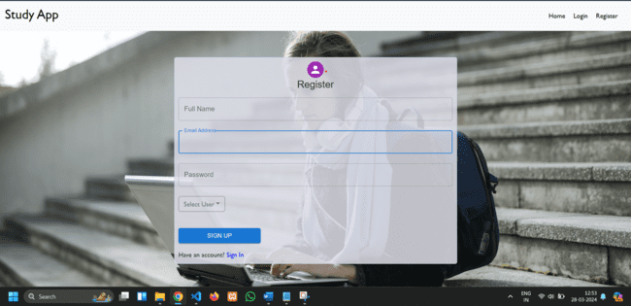A screenshot of a computer

     AI-generated content may be incorrect.A screenshot of a computer

     AI-generated content may be incorrect.A screenshot of a computer

     AI-generated content may be incorrect.A screenshot of a computer

     AI-generated content may be incorrect.A screenshot of a computer

     AI-generated content may be incorrect.

**10. Testing**

Testing was done using:

* Manual testing for all UI flows
* Postman for API endpoint testing
* Load testing with Apache JMeter

**11. Screenshots or Demo**

* Github Repository:[**https://github.com/deepikamukku83/LearnHub-**](https://github.com/deepikamukku83/LearnHub-)

**12. Known Issues**

* Live chat is not real-time (refresh needed)
* Some responsiveness issues on small screens

**13. Future Enhancements**

* Add AI-based course recommendations
* Mobile app version
* Real-time chat and announcements
* Dark/light theme toggle

**Appendix A: Ideation Phase – Brainstorm & Idea Prioritization**

**Team Gathering & Collaboration:** Our team initiated the project by organizing a virtual brainstorming session to bring together diverse ideas and explore real-world problems that can be solved through technology. Each member was encouraged to share pain points they personally experienced or observed in their daily lives. The discussion focused on areas such as education, accessibility, and skill development.

**Initial Brainstormed Ideas:**

1. Smart School Attendance System
2. Online Learning Platform with Progress Tracking
3. College Event Scheduler
4. Digital Exam Proctoring Tool
5. Career Guidance Portal

**Prioritization Criteria:**

* Relevance and urgency of the problem
* Feasibility of solution within project timeline
* Technical scope and learning opportunities
* User base and social impact potential

**Selected Idea – LearnHub:Your Center for Skill Enhancement:**After careful analysis and ranking based on feasibility, scope, and user demand, we finalized our problem statement around the lack of flexible and engaging platforms for self-paced skill development. We selected OLP, a full-stack educational platform, allowing users to browse, enroll, and complete courses while tracking their progress and earning certifications.

This idea resonated with all team members and allowed us to incorporate a variety of technical concepts including React, Node, Express, MongoDB, and JWT authentication, while solving a meaningful educational challenge.